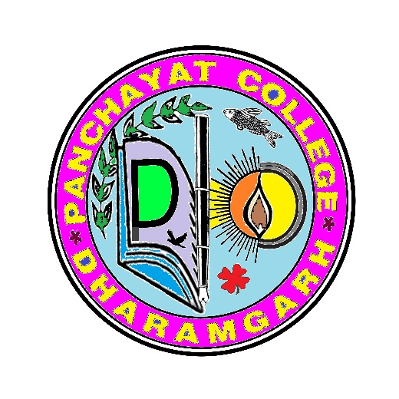

THE COLLEGE CREST
• The outer circle stands for gathering unmeasurable wisdom and embrace the aspirant human mind, to ignite the pursuit of knowledge to dispel the enveloped darkness of ignorance and superstitions as well as to curb down age old social stigma and mentel inertia widening the far-reaching horizon of academic depth.
• Inner circle stands as the basin of knowledge and wisdom.
• The sun symbolizes as the embodiment of knowledge that dispels the darkness and embark on a new horizon of bright future.
• Alphabets P C D denotes outwardly the Panchayat College , Dharamgarh but in perception it represents
P = Pure mind
C = Commitments towards Academic Excellence
D = Dignity of knowledge
- The symbolic representation of lightened lamp indicates the joy of knowledge and life giving power. All the way it leads to academic brightness .

- Green paddy stuff is the symbol of country – side village agriculture icon. As the college is based on the rural set-up of agricultural aspiration and the area is well known as rice bowel of Odisha, so green paddy stuff represents the socio-economic growth . A dream symbol green and luxurious corn, also symbolizes love, faith, locality and friendship.

- .The fish symbolizes the watery domain features as well as depth of knowledge. Water springs life and fish represents the meaning of fertility, eternity, creativity, good luck and transformation, determination and flow of life all together.

- Flying bird is the symbol of freedom and ability, able to fly multiple places, usually of vast distance one can become bird like through the spirit of its ability and courage.
- Pen represents education and intelligence. It symbolizes wisdom which comes from the experience and realization of expanded consciousness. In its tip actual ball that rolls to gather the knowledge for life and society at large.

- Flower is the symbol of aroma of life which one can bloom and spread through knowledge and intelligence.

